YOUTH MEMBERSHIP FAQ

1. What is Youth Alumni Membership about?

The Youth Alumni Membership seeks to establish the link between the Gabrielites and those who have just left school. The main purpose is for youth members is to contribute to both alumni and school activities as youth volunteers.

2. What are the benefits to join as a Youth Alumni?

As a Youth Alumni, you will be connected via social media platforms and receive occasional postal mailings on school events.Opportunities would be provided for you to return to our Gabrielite Schools to participate and volunteer in alumni and school based activities,and to also stay connected with your teachers and classmates. In essence, the Youth Alumni is a platform to enable you to stay connected and continue the sense of belonging to St Gabriel’s through shared community.

3. What are the charges to join as a Youth Alumni?

Your Youth Membership is free of charge until you turn 25 years old; thereafter your Youth Membership would cease. You can convert to our various membership schemes anytime from the age of 21 years old:

- Ordinary Membership with a one time subscription of $200

4. What is the criteria to join as a Youth Alumni?

You are eligible to join if:
- You have graduated from St Gabriel’s Primary School, St Gabriel’s Secondary School or St Gabriel’s School.
- You are below the age of 25 years old.

Youth membership will terminate on 31 December in the year they attain the age of 25 or when they become Ordinary Members or Life Members.

Youth members may at any time convert their membership after the age of 21 after paying up the relevant subscription fees.

5. Do I have voting rights at the Gabrielite Annual General Meetings (AGM)?

Voting rights are only for those with Ordinary or Life Membership.

6. Which Registration Phase will a Youth Alumni Member be eligible for under Primary One Registration Process?

Your Youth Alumni membership status is different from an Ordinary or Life Membership status. If you were from the Primary School, you would be eligible for Phase 2A(2). After you have turned 21 years old, you will be eligible to apply to convert your Youth Membership into an Ordinary or Life Membership.

When you grow older and have your own family, your child would enter the school at an earlier phase at Phase 2A(1) once you become an Ordinary Member and Life Member,

Useful Links: https://www.facebook.com/groups/151637898241650/

St Gabriel`s Old Boys` Association (formed in 1961)

SECTION 1: PERSONAL PARTICULARS |  | Youth Membership  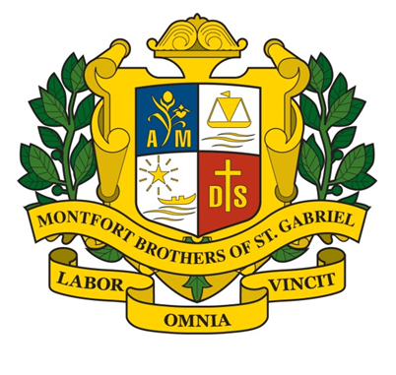
Name

NRIC Number:

Nationality:

Date of Birth: Age:

Year of Graduation
Year of Graduation from the Primary school (SGPS): | Year of Graduation from the Secondary school (SGSS):
Home Address:__________________________________________________________________________
__________________________________________________________________________
Postal Code __________________ E-mail Address :_________________________________
Home Telephone No. ____________________ Mobile phone No. ________________________

Present Occupation:
My interest(s) / My proposed area(s) of contribution :

I, ______________________________________________ (Name) __________________ (NRIC) declare that the information provided above is true and accurate as at date: ________________________ Signature : ________________________

